**PHP ASSIGNMENT 2. Ayushi Srivastava**

**181500185**

**H-11**

((1)).Explain the concept of nested table,rowspan and colspan attribute in HTML5,create a table for the following data i.e Product name,Product ID,Product quantity,Product price and at last show you have to show a total amount in colspan.

Ans->Nested table in html means creating a table on a web-page inside another table on the same web-page.The rowspan and colspan are <td> tag attributes.these are used to specify total no of rows and columns in a cell should span.Rowspan for rows as well as Colspan for columns.

<html>

<head>

<title> table</title>

</head>

<body>

<tr>

<td> <table border="3" width=95% height=85%>

<caption>Product details</caption>

<tr>

<th>PRODUCT ID</th>

<th>PRODUCT NAME</th>

<th>PRODUCT QUANTITY</th>

<th>PRODUCT PRICE</th>

</tr>

<tr>

<td>001</td>

<td>Tata tea premium</td>

<td>2</td>

<td>600</td>

</tr>

<tr>

<td>002</td>

<td>Close Up toothpaste</td>

<td>4</td>

<td>240</td>

</tr>

<tr>

<td>003</td>

<td>Set Wet Perfume</td>

<td>3</td>

<td>180</td>

</tr>

<tr>

<th colspan="3">Total amount</th>

<td>1020</td>

</tr>

</table>

</td>

</tr>

</body>

</html>

## output->

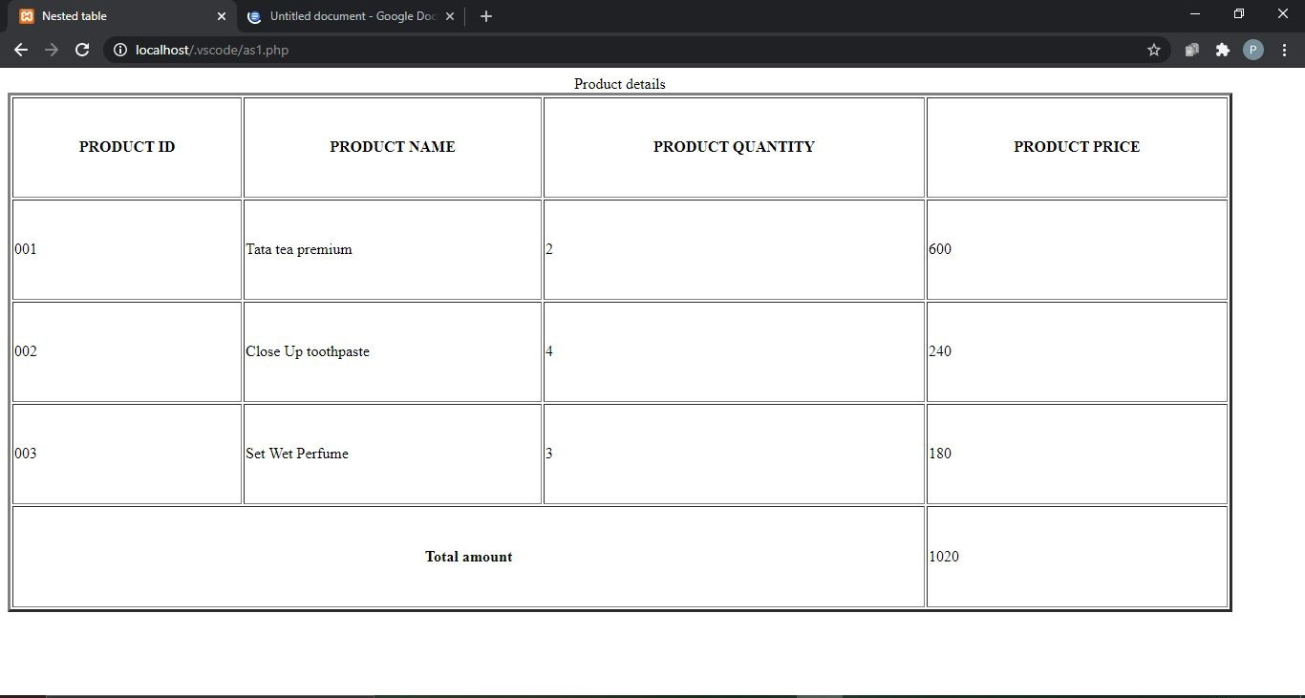

### ((2))Write a php script to print all natural numbers from 1 to n using while loop.

Ans->

<html>

<body>

<form method="post">

<p>Enter end number upto which you want to print natural numbers</p> End number:<input type="number" name="num">

<input type="submit" name="submit">

</form>

</body>

<html>

<?php

$num=$_POST['num'];

$i=1; while($i<=$num){

echo $i . "</br>";

$i++;

}

?>

### Output->

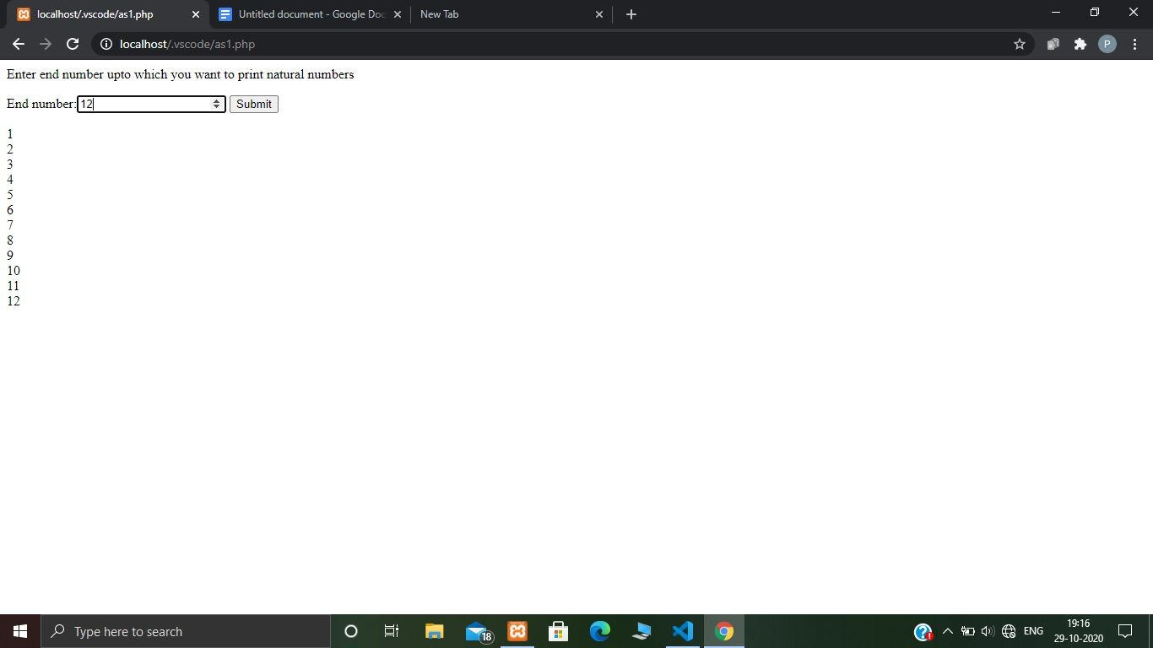

((3))Write a php script to print all natural numbers in reverse order from n to 1 using while loop.

Ans->

<html>

<body>

<form method="post">

<p>Enter end number you want to print natural numbers in reverse order</p> End number:<input type="number" name="num">

<input type="submit" name="submit">

</form>

</body>

<html>

<?php

$num=$_POST['num'];

$i=1; while($i<=$num){

echo $num . "</br>";

$num--;

}

?>

## Output->

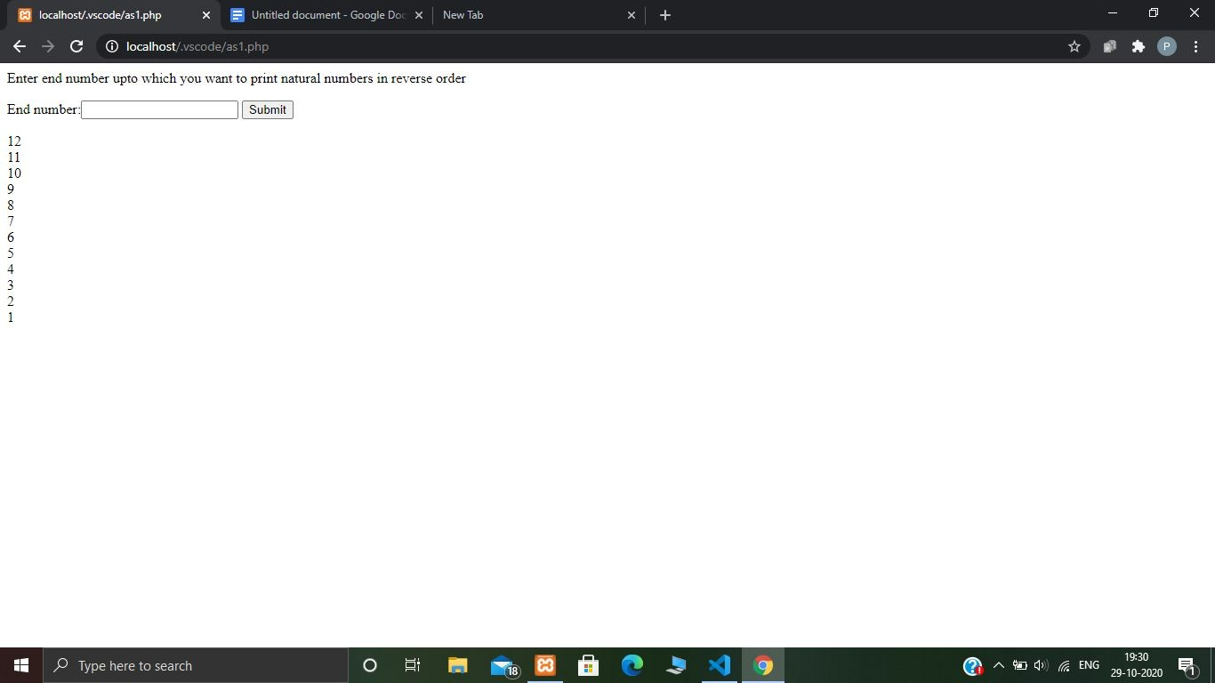

((4))Write a php script to print all alphabets from a to z.

Ans->

### <?php

foreach(range('a','z')as $char){ echo $char . "</br>";

}

?>

Output->



((5))Write a php script to print all even numbers between 1 to 100 using while loop.

Ans->

<?php

echo "Even numbers from 1 to 100 are </br>"; for($i=1;$i<=100;$i++) { if($i%2==0) {

echo $i." , ";

}

}

?>

Output->

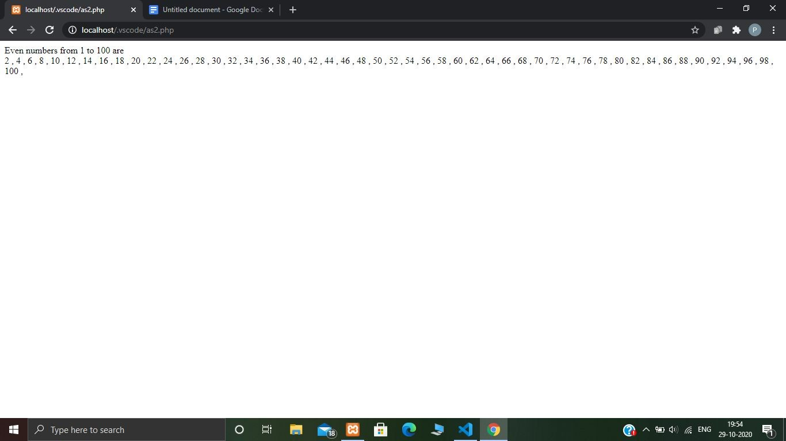

((6))Write a php script to print all odd numbers between 1 to 100.

Ans->

<?php

echo "Odd numbers from 1 to 100 are </br>"; for($i=1;$i<=100;$i++) {

if($i%2!==0) {

echo $i." , ";

}

}

?>

### Output->

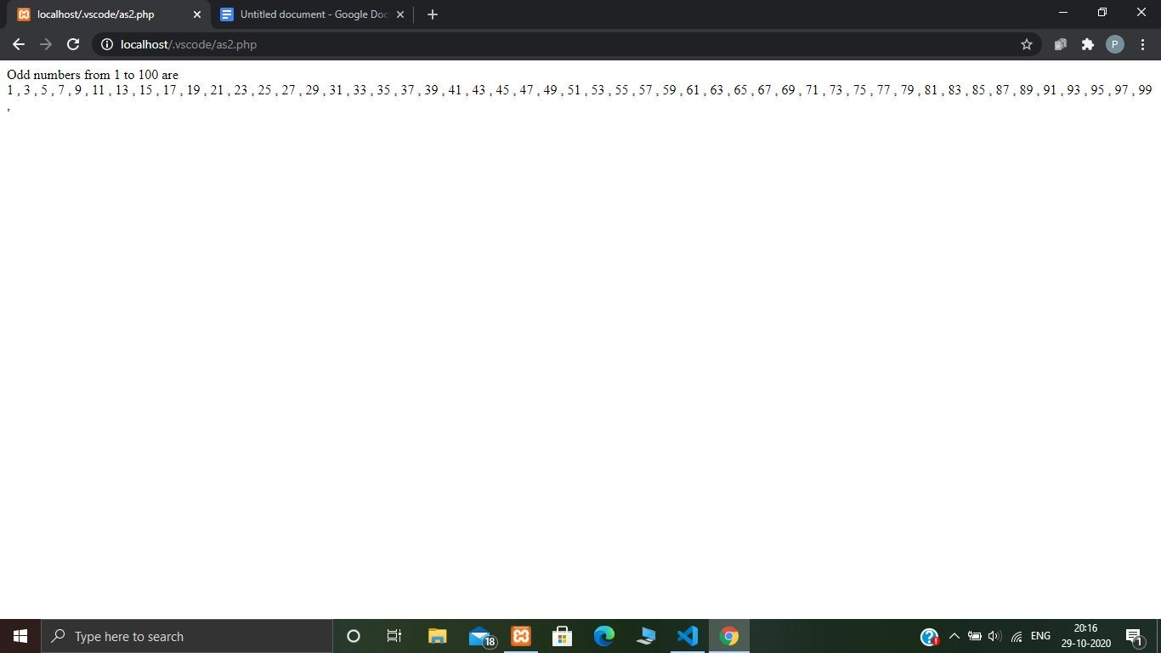

((7))Write a php script to find the sum of all natural numbers between 1 to n.

Ans->

<html>

<title> Sum of natural numbers </title>

<body>

<?php

echo"Enter value of n to add sum of natural numbers from 1 to n <br>";

?>

<form method = "post">

n: <input type="number" name="n">

<br>

<input type = "submit" name = "submit" value="Print">

</form>

<?php if(isset($_POST['submit']))

{

$n = $_POST['n'];

echo "The sum of natural numbers between 1 and $n are :<br>";

$i=1;

$sum = 0; while($i <= $n)

{

$sum += $i;

$i++;

}

echo "$sum";

}

?>

</body>

</html>

## Output->

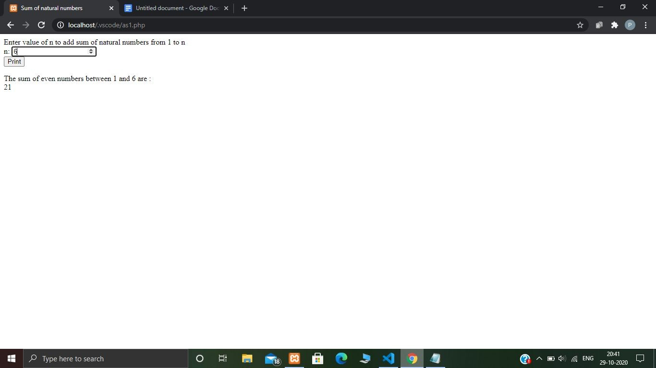

((8))Write a php script to find the sum of all even numbers between 1 to n.

Ans->

<html>

<title> Sum of even numbers </title>

<body>

<?php

echo"Enter value of n to add sum of even numbers from 1 to n <br>";

?>

<form method = "post">

n: <input type="number" name="n">

<br>

<input type = "submit" name = "submit" value="Print">

</form>

<?php if(isset($_POST['submit']))

{

$n = $_POST['n'];

echo "The sum of even numbers between 1 and $n are : <br>";

$i=1;

$sum = 0; while($i <= $n)

{

if($i % 2 == 0)

$sum += $i;

$i++;

}

echo "$sum";

}

?>

</body>

</html>

# Output->

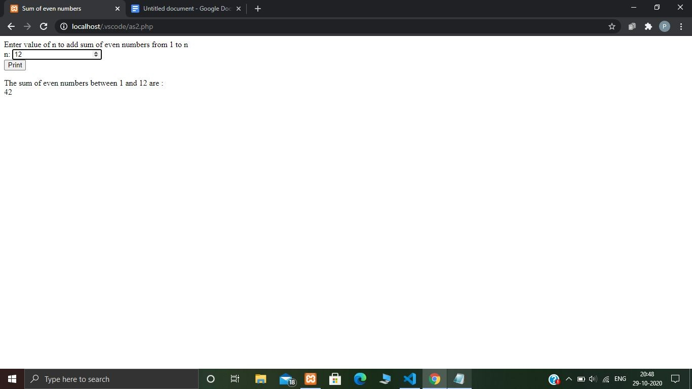

((9))Write a php script to find the sum of all odd numbers between 1 to n.

Ans->

<html>

<title> Sum of odd numbers </title>

<body>

<?php

echo"Enter value of n to add sum of odd numbers from 1 to n <br>";

?>

<form method = "post">

n: <input type="number" name="n">

<br>

<input type = "submit" name = "submit" value="Print">

</form>

<?php if(isset($_POST['submit']))

{

$n = $_POST['n'];

echo "The sum of odd numbers between 1 and $n are :<br>";

$i=1;

$sum = 0; while($i <= $n)

{

if(($i%2)!==0)

$sum += $i;

$i++;

}

echo "$sum";

}

?>

</body>

</html>

# Output->

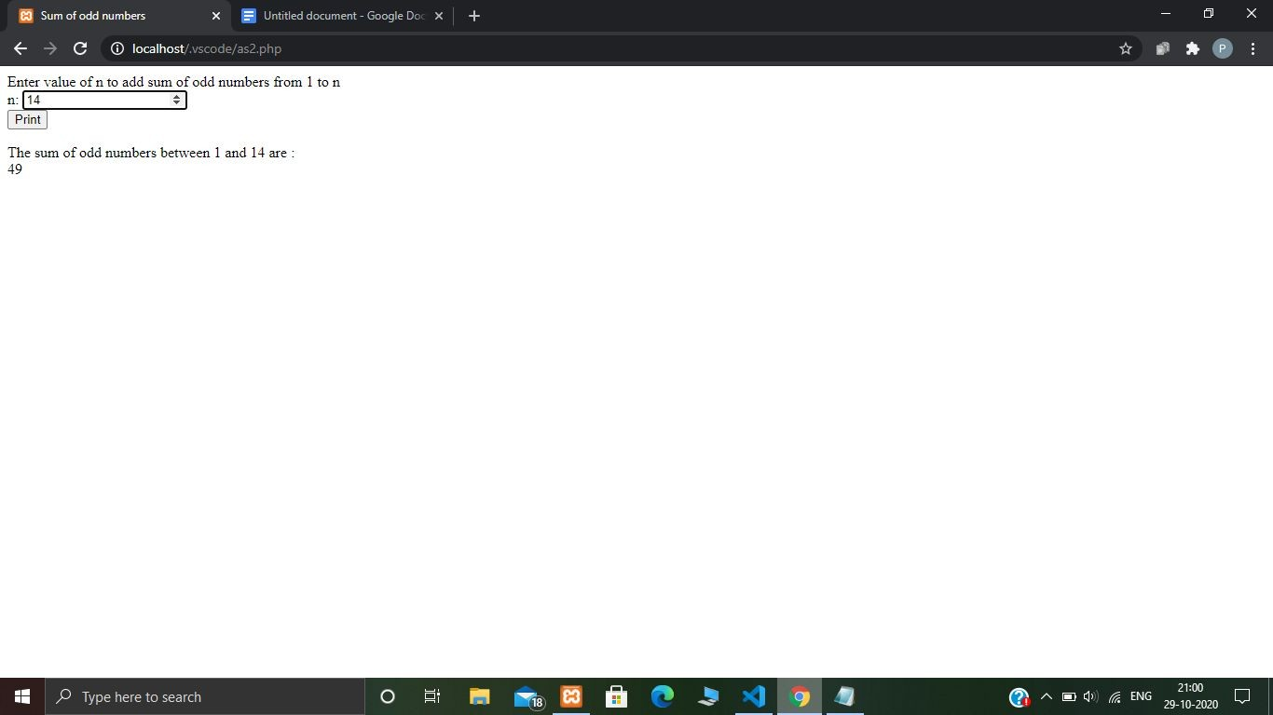

((10))Write a php script to print a multiplication table of any number.

Ans->

<html>

<title> Multiplication Table </title>

<body>

<?php

echo"Enter a number to print multiplication table of that number <br>";

?>

<form method = "post">

n: <input type="number" name="n">

<br>

<input type = "submit" name = "submit" value="Print">

</form>

<?php if(isset($_POST['submit']))

{

$n = $_POST['n'];

echo "The multiplication table of given $n is :<br>"; for($i=1;$i<=10;$i++){

$mul=$n*$i;

echo $mul . "</br>";

}

}

?>

</body>

</html>

## Output->

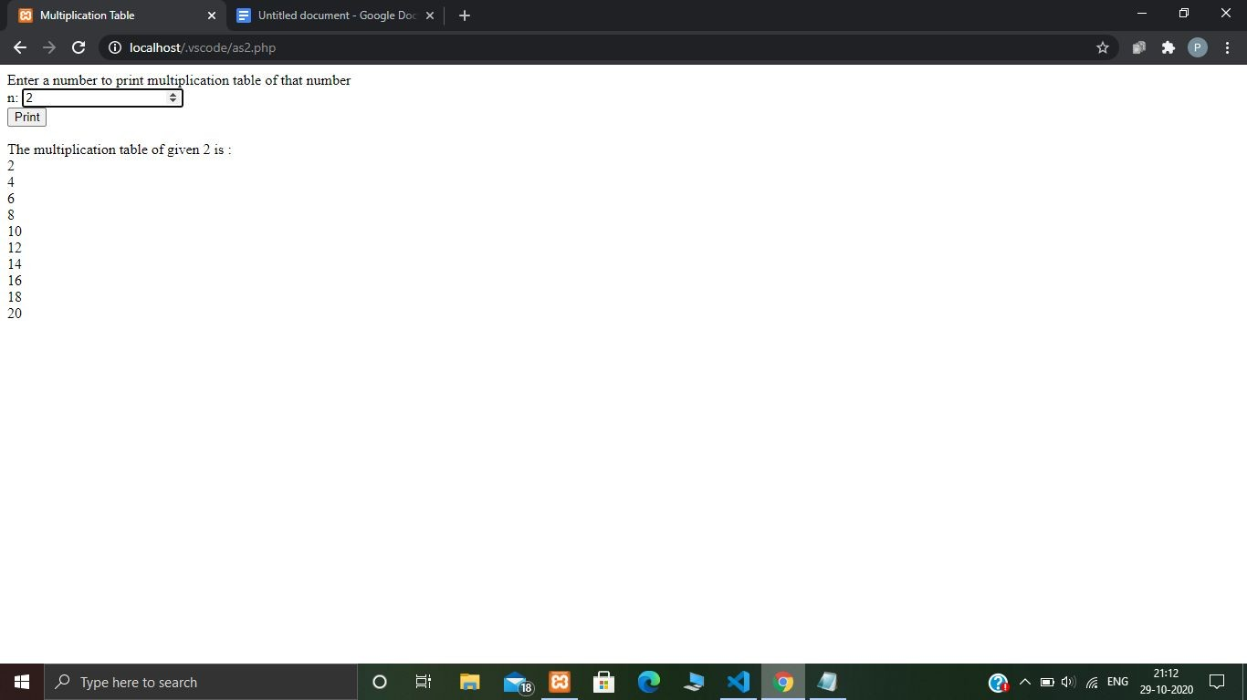

((11))Write a php script to count the number of digits in a number.

Ans->

<html>

<title> Count no of digits </title>

<body>

<?php

echo"Enter a number to for count number of digits <br>";

?>

<form method = "post">

n: <input type="number" name="n">

<br>

<input type = "submit" name = "submit" value="Print">

</form>

<?php if(isset($_POST['submit']))

{

function sum($n){

$sum=0; for($i=0;$i<strlen($n);$i++){

$sum +=$n[$i];

}

return $sum;

}

$n = $_POST['n'];

echo "The total count of digits of given $n is: </br>"; echo sum($n);

}

?>

</body>

</html>

## Output->

